Edexcel BTEC Level 1
Award/Certificate/Diploma in

IT Users (ITQ) (QCF)

Unit 121: Imaging Software
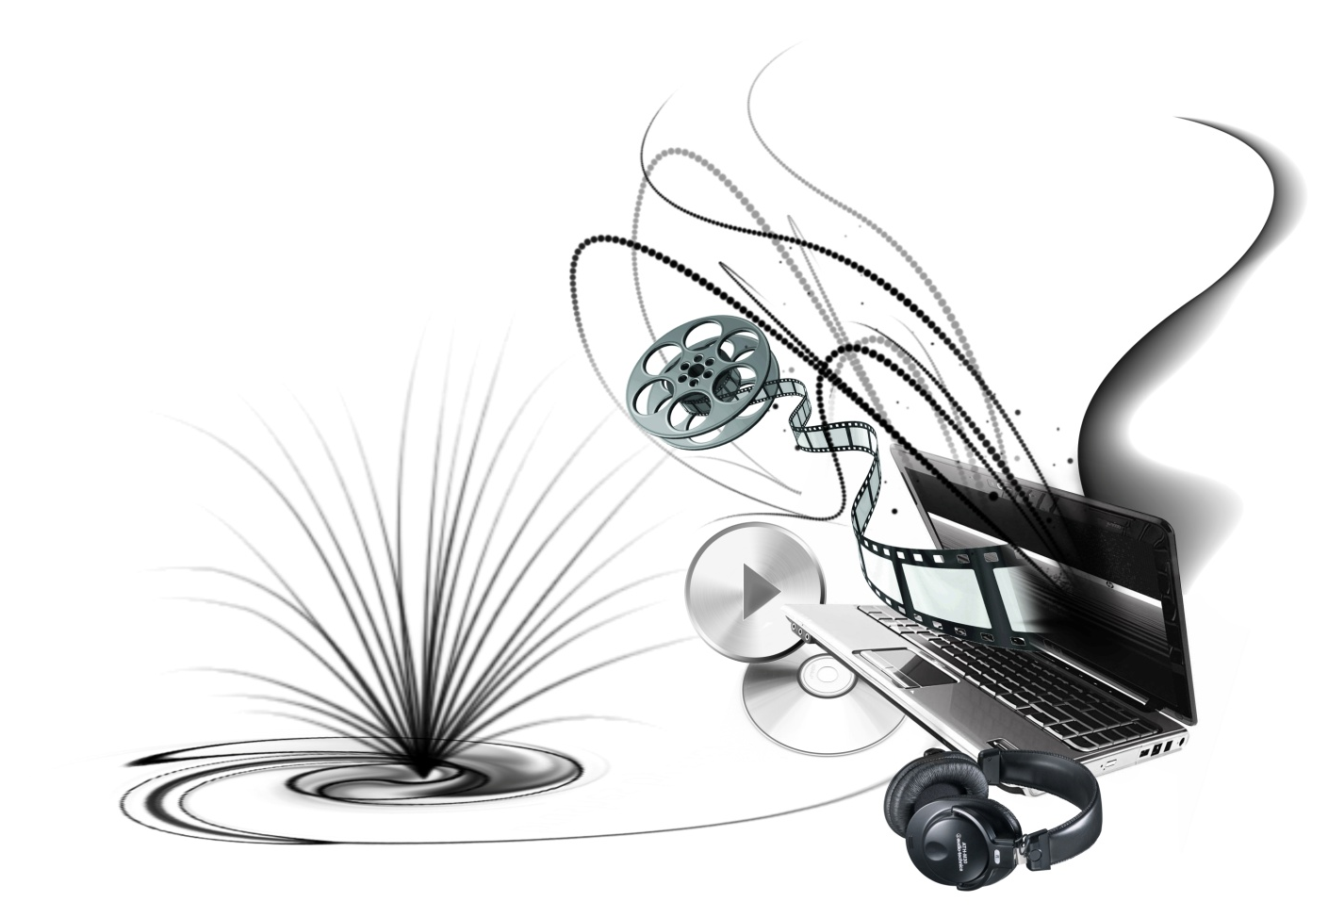
Assignment 121

Contents

Index |  | Page No
Learner details* |  | 3
Learner tracker* |  | 3
Learner declaration* |  | 3
Unit Summary |  | 4
Assessment requirements/evidence requirements |  | 4
Assessment methodology |  | 4
Learning outcomes |  | 5
Assessment and grading criteria |  | 5
Unit contents |  | 6
Delivery |  | 7
Assessment |  | 7
Assignment brief |  | 8
Task 1 |  | 9
Task 2 |  | 10
Task 3 |  | 11
* Must be submitted with learner’s evidence.
Assignment 121 – Unit 121: Imaging Software

Learner Name:
Assessor Name:
Issue Date:
Deadline Date:
Submission Date:
Learner Tracker
Assignment 1 | Assessment Criteria | Completed | Grade
Task 1 | 1.1 / 1.3 / 1.5 & 1.6
Task 2 | 1.2 / 1.4 & 1.7
Task 3 | 2.1 / 2.2 & 2.3

Learner Declaration
The learner declaration must be attached to the completed portfolio of evidence.
Learner Name:
I declare that the work contained in this portfolio of evidence is all my own work.
Learner Signed:
Date:
I declare that the work contained in this portfolio of evidence is all the work of the above learner.
Assessor Name:
Assessor Signed:
Date:

Unit 121: Imaging Software

Unit code: J/502/4612

QCF Level: Level 1
Credit value: 3

Unit summary

This unit is about the skills and knowledge required by an IT user to use basic imaging software tools and techniques appropriately to produce straightforward or routine images. Any aspect that is unfamiliar will require support and advice from others.

Imaging software tools and techniques will be described as ‘basic’ because:

• the range of inputting, manipulation and outputting techniques will be straightforward or routine;
• the software tools and functions involved will be predefined or commonly used;
• the type and structure of the task will be predetermined or familiar.

Assessment requirements/evidence requirements

Evidence of achievement can be derived from a variety of sources.
Learners who use their IT skills directly in their day-to-day work can prove their competence whilst doing so. Alternatively learners can use scenarios and knowledge tests - or a mixture of both - to demonstrate competence.

Assessment methodology

All ITQ units may be assessed using any method, or combination of methods, which clearly demonstrates that the learning outcomes and assessment criteria have been met.

Whilst assessors are required to have a sound understanding of the unit requirements and be able to give appropriate feedback to learners, they do not have to be A1 qualified. However, ideally every assessor should have ITQ Level 3 or equivalent in order to be able to adequately assess at that
level and below.
Learning outcomes and assessment criteria
In order to pass this unit, the evidence that the learner presents for assessment needs to demonstrate that they can meet all the learning outcomes for the unit. The assessment criteria
determine the standard required to achieve the unit.

On completion of this unit a learner should:

Learning outcomes | Assessment criteria
1 Obtain, insert and combine information for images. | - Identify what images are needed.  - Obtain, insert and prepare images to meet needs.  - Identify what generic copyright and other constraints apply to the use of images.  - Combine information for different forms or from different sources for images.  - Identify the context in which the images will be used.  - Identify which file format to use for saving and exchanging images.  - Store and retrieve image files effectively, in line with local guidelines and conventions where available.
2 Use imaging software tools to create, manipulate and edit designs or images. | - Use suitable tools and techniques to create images.  - Use appropriate tools and techniques to manipulate and edit images.  - Check images meet needs, using IT tools and making corrections as appropriate.

Unit content

1 Obtain, insert and combine information for images.

Images: will vary according to the task eg photos from a digital camera, scanned images, graphic elements, drawings, clip art.
Prepare images: size, crop and position.
Combining information techniques: insert, size, position, wrap, order, group.
Copyright constraints: effect of copyright law eg on music downloads or use of other people’s images, acknowledgement of sources, avoiding plagiarism, permissions.
Context for images: contexts will vary according to the software and task eg on-screen display, publishing on a website, hard-copy printout, digital file.
File format for images: will vary according to the content, proprietary and open-source formats eg JPEG, Bitmap, PNG, GIF.
Store and retrieve: files eg create, name, open, save, save as, find.

- Use imaging software tools to create, manipulate and edit designs or images.

Create images: draw basic shapes; change properties eg line width and fill colour, download digital photos from a camera, scan and resize images, add text and other elements eg lines, boxes, arrows
Manipulation and editing techniques: align, rotate, flip, arrange, cut, paste, resize, change font, text, colour.
Check images: eg size, alignment and orientation, suitability of file format.
Delivery
A practical approach to delivery is essential for this unit. Delivery should focus on both the format and the content of software as well as enabling learners to develop their technical knowledge and skills by using software tools and techniques. Much of the assessment evidence is likely to be produced during this process, and centres should consider what other supporting product evidence can be collected. This unit can be taught in conjunction with other units eg
Unit 101: Improving Productivity using IT, Unit 112: IT Software Fundamentals, Desktop Publishing Software, Unit 124: Multimedia Software, Unit 125: Presentation Software, Unit 127: Spreadsheet Software and Unit 128: Website Software and Unit 129: Word processing Software and has particularly close links with Unit 120: Design Software.

Assessment
An holistic approach to teaching is suggested for this unit. Tutors should provide learners with a variety of scenarios, from which one should be selected. These scenarios should be of interest to the learners and should not be too ambitious but should enable them to meet all the assessment criteria. It is envisaged that only scenario be required in order for learners to fulfil what is needed to pass the unit.

Tutors should encourage learners to capture and record evidence as an ongoing process at each stage of development. Therefore, assessment evidence will primarily come in the form of printed annotated screen shots, highlighting the formatting and layout of work, where necessary.
Evidence can also come in the form of observations, class discussions, peer assessment and written work.

To achieve a pass grade in this unit, learners will need to meet all of the assessment criteria.

Indicative resource materials

Textbooks

Bouton G D – CorelDRAW® X4: The Official Guide (McGraw-Hill Osborne, 2008) ISBN-13 978-0071545709
Brundage B – Photoshop Elements 7: The Missing Manual (Pogue Press, 2008) ISBN-13 978-0596521332
McMahon K – Paint Shop Pro Photo X2 for Photographers (Focal Press, 2007) ISBN-13 978-0240520896

Websites
http://office.microsoft.com/en-gb/clipart/default.aspx
Assignment brief

This assignment comprises of all the assessment requirements for the completion of Unit 26: Word Processing Software.

This assignment is made up of 1 scenario and 3 tasks. You MUST complete all tasks successfully to gain full unit accreditation.

Time allowance
The recommended time allowance for this assignment is 20 guided learning hours. This will give you approx 6 hours and 40 minutes per task.

Health and safety
You are responsible for maintaining the safety of others as well as yourself. You are asked to work safely at all times.

You will not be allowed to continue with this assignment if you compromise any of the Health and Safety requirements.

Evidence
All evidence MUST be of your own work and signed by you and your assessor. It is good practice to submit research evidence to support your own work.

Evidence requirement list
Task | Evidence | Assessment Criteria
1 |  | 1.1 / 1.3 / 1.5 & 1.6
2 |  | 1.2 / 1.4 & 1.7
3 |  | 2.1 / 2.2 & 2.3

Assignment 121 - Unit 121: Imaging Software

Scenario
As part of your apprenticeship at Design 4 Life Media Ltd, Newport, you have been placed in the graphics department to increase your knowledge and experience of graphics/design software.

Your manager has asked you to come up with two suitable logos for the company, one that can be used on letterheads and posters and one that can be used on the company website.

You have to plan your designs using the images your graphics department have provided and each design has to incorporate text.

It has been requested that each picture is used a minimum of once for each design unless there is a copyright issue with it.

Your designs have to be sized appropriately and have the appropriate resolution for the media they are intended to be used for.

Please read all of the tasks before beginning.

Task 1

- Create a plan that you can use when designing your logos.

- You will have to identify
  - what images are required,
  - where you will obtain them and
  - check them for any copyright restrictions.

- You have to plan
  - what media the logos are to be used for,
  - what format,
  - resolution and file size will be required for the different media and
  - what file type will be best for saving them.

Ensure you have covered all three points below in order to complete this task

- Identify what images are needed: This will vary according to the task e.g. getting photos from a digital camera, scanned images, graphic elements, drawings, clip art.

- Identify what generic copyright and other constraints apply to the use of images: the effect of copyright law e.g. on music downloads or use of other people’s images, the acknowledgement of sources, avoiding plagiarism, permissions.

- Identify the context in which the images will be used: The contexts will vary according to the software and task e.g. on-screen display, publishing on a website, hard-copy printout, digital file.

- Identify which file format to use for saving and exchanging images: This will vary according to the content and may include proprietary and open-source formats e.g. JPEG, Bitmap, PNG, GIF.

(1.1, 1.3, 1.5, 1.6)

Task 2
- Using your imaging software, create your first logo. Please screenshot every tool and technique you use.

- Open your images in the Imaging software and combine them, using any editing tools or techniques available to you create your design.

- Check that the size and resolution of this design is appropriate for PRINT purposes.

- Print an actual size copy of your design and write your name on the top.

- Save your design as “LogoPrint” using the appropriate file format for print.

Ensure you have covered all three points below in order to complete this task

- Obtain, insert and prepare images to meet needs: size, crop and position.

- Combine information for different forms or from different sources for images: insert, size, position, wrap, order, group.

- Store and retrieve image files effectively, in line with local guidelines and conventions where available: files e.g. create, name, open, save, save as, find.

(1.2, 1.4, 1.7)

Task 3

- Using your imaging software, create your second logo. Please screenshot every tool and technique you use.

- Your graphics department has told you that the logo for the website has to be altered to have a black background and white text.

- Open your images in the Imaging software and combine them, using any editing tools or techniques available to you create your design.

- Check that the size and resolution of this design is appropriate for SCREEN DISPLAY/WEB purposes.

- Print an actual size copy of your design and write your name on the top.

- Save your design as “LogoWeb” using the appropriate file format for screen display/web.

Ensure you have covered all three points below in order to complete this task

- Use suitable tools and techniques to create images: draw basic shapes; change properties e.g. line width and fill colour, download digital photos from a camera, scan and resize images, add text and other elements such as lines, boxes, arrows.

- Use appropriate tools and techniques to manipulate and edit images: align, rotate, flip, arrange, cut, paste, resize, change font, text, colour.

- Check images meet needs, using IT tools and making corrections as appropriate: e.g. size, alignment and orientation, suitability of file format.

(2.1, 2.2, 2.3)

End of assignment

